**Chapter IX – Producing HTML Output**

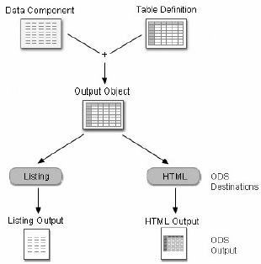HTML is the default output of SAS

1. Simple ODS statement

* Function:
* Creates a output in the form of output objects
* Sends the output object to the ODS destinations that you specify and creates formatted output as specified by the destination
* Creates a link to each output object in the Result window, and identifies each output object by the appropriate icon
* ODS Destinations

|  |  |
| --- | --- |
| Destinations | Produces |
| HTML (Hypertext Markup Language) | Default format, don’t need to specify |
| Listing | Plain text output |
| Markup Language Family | Such as Extensible Markup Language (XML) |
| Document | a hierarchy of output objects that enables you to render multiple ODS output without rerunning procedures |
| Output | SAS data set |
| Printer Family | Format for high-resolution printer such as PostScript, PDF |
| RTF (Rich Text Format) | Use with Word |

* Basic code to Open and Close destinations :

**ODS** *open-destination***;**

**ODS** *close-destination* **CLOSE;**

*open-destination* is a keyword and any required options for the type of output that you want to create, such as

**HTML FILE**=*'html-file-pathname'* **Default ODS Destination**

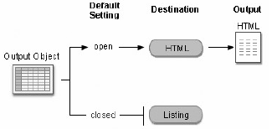**LISTING**

*close-destination* is a keyword for the type of output

* + Most ODS destinations are closed by default. Normally, open at the beginning and close at the end of the program

Eg:

Produces HTML and Listing format:

**ODS** listing;

**PROC** **PRINT** data=sasuser.mydata;

**RUN**;

**ODS** listing close;

注意：如果不设定ODS HTML Close，output回自动显示HTML和设定的output format

* + HTML closed after CLOSE option until you end current SAS session or until reopen the destination
  + Better reset ODS to HTML at the end of the program
* Multiple ODS Destinations (Beginning of the program)
* use the keyword _ALL_ in the ODS CLOSE statement to close all open destinations at once

Eg:

**ODS** **RTF** file='RTF-file-pathname';

**ODS PDF** file='PDF-file-pathname';

**PROC PRINT** data=sasuser.admit;

**RUN**;

**ODS** _**ALL**_ close;

**ODS** **HTML**;

1. ODS statement with Options

Need a the ODS HTML statement to create HTML output with options specified

**FILE** has the same function as **BODY**, and also can the PATH= option to explicitly specify a directory path for your file

* Basic code:

**ODS HTML BODY=***file-specification***;**

**ODS HTML CLOSE;**

where *file-specification* identifies the file that contains the HTML output.

* Quoted string which contains the HTML filename:

Only to write the file to your current working directory location

Eg:

**ODS HTML BODY**=*“myreport.html”*;

* Quoted string which contains the complete directory path and HTML filename

Want to save the HTML file to a specific location other than your working directory

Eg:

**ODS HTML BODY**=*“c:\reportdir\myreport.html”*;

* A fileref (unquoted file shortcut) that has been assigned to an HTML file using the FILENAME statement

Eg:

**FILENAME MYHTML** *“c:\reportdir\myreport.html”*;

**ODS HTML BODY**=MYHTML;

* SAS catalog

Catalog name is specified in the PATH= option and the entry-name.html value for the BODY= option is unquoted

Eg:

**ODS HTML PATH**=*work.mycat* **BODY**=*myentry***BODY**=.**HTML**;

1. Creating HTML Output from Multiple Procedures

ODS HTML statement to direct the results from multiple procedures to the same HTML file.

Eg:

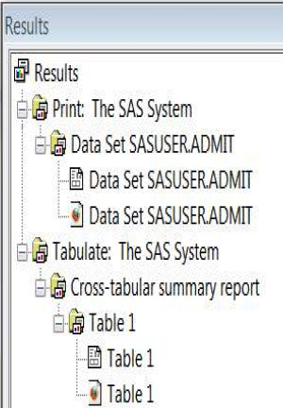The program below generates HTML output for the PRINT and TABULATE procedures. The results for both procedures are saved to the file **C:\Records\data.html** in the Windows environment. A link for each output object (one for each procedure) appears in the Results window.

**ODS HTML BODY**='c:\records\data.html';

**PROC PRINT** data=clinic.admit LABLE;

**VAR** id sex age height weight actlevel;L

**LABLE** actlevel='Activity Level';

**RUN**;

**PROC TABULATE** data=clinic.stress2;

**VAR** resthr maxhr rechr;

**TABLE** min mean, resthr maxhr rechr;

**RUN**;

**OBS HTML** close;

1. Creating HTML Output with a Table of Contents

* A table of contents with links to the output of each specific procedure
* The Results window does not display links to frame files. In the Windows environment, only the body file will automatically appear in the internal browser or your preferred Web browser.
* Basic code:

**ODS HTML**

**BODY=***body-file-specification*

**CONTENTS=***contents-file-specification*

**FRAME=***frame-file-specification***;**

**ODS HTML CLOSE;**

***body-file-specification*** is the name of an HTML file that contains the procedure output.

***contents-file-specification***is the name of an HTML file that contains a table of contents with links to the procedure output.

***frame-file-specification***is the name of an HTML file that integrates the table of contents and the body file. If you specify FRAME=, you must also specify CONTENTS=.

Eg:

In the program below,

* + - * The BODY= specification creates data.html in the c:\records directory. The body file contains the results of the two procedures.
      * The CONTENTS= specification creates toc.html in the c:\records directory. The table of contents file has links to each procedure output in the body file.
      * 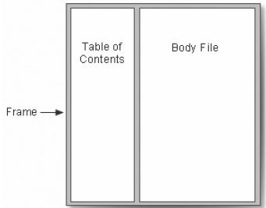The FRAME= specification creates frame.html in the c:\records directory. The frame file integrates the table of contents and the body file.

**ODS HTML BODY**='c:\records\data.html'

**CONTENTS** ='c:\records\toc.html'

**FRAME**='c:\records\frame.html';

**PROC PRINT** data=clinic.admit label;

**VAR** id sex age height weight actlevel;

**LABLE** actlevel='Activity Level';

**RUN**;

**PROC** **PRINT** data=clinic.stress2;

**VAR** id resthr maxhr rechr;

**RUN**;

**ODS** **HTML** **CLOSE**;

**ODS** **HTML**;

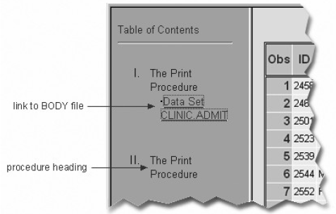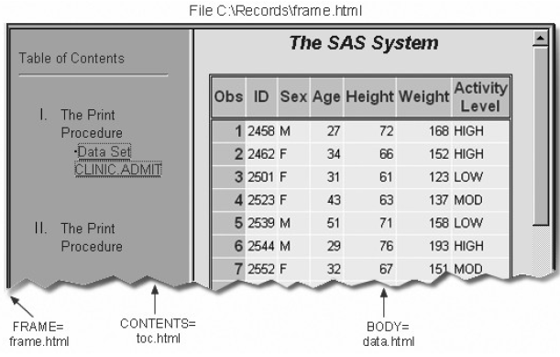

1. Using Options to Specify Links and Paths

* When ODS generates HTML files for the body, contents, and frame, it also generates links between the files using the HTML filenames that you specify in the ODS HTML statement
* 在以上例子中，ODS statement creates a frame file that has links to **c:\records\toc.html** and **c:\records\data.html**, and a contents file that has links to **c:\records\data.html**.

1. The **URL=** Suboption

* **URL** links the file to the web
* By specifying the **URL**= suboption in the **BODY**= or **CONTENTS**= file specification, you can provide a **URL** that **ODS** uses in all the links that it creates to the file. You can use the **URL**= suboption in any **ODS** file specification except **FRAME**= (because no **ODS** file references the frame file).
* **URL** is useful when the **HTML** file may be moved from one location to another. If the link is construted with a simple **URL**, work as long as the contents, page, and body files are all in the same location

Eg:

**(URL=***'Uniform-Resource-Locator'***)**

where *Uniform-Resource-Locator* is the name of an **HTML** file or the full **URL** of an **HTML** file. **ODS** uses this **URL** instead of the file specification in all the links and references that it creates that point to the file.

* **Relative URL**
* The URL= suboption specifies only the HTML filename
* The most common style of linking between files
* Can be moved as long as they all remain in the same directory or storage location

Eg:

**ODS HTML BODY**='c:\records\data.html' (url='data.html')

**CONTENTS**='c:\records\toc.html' (url='toc.html')

**FRAME**='c:\records\frame.html';

***Source Code Frame.html*** 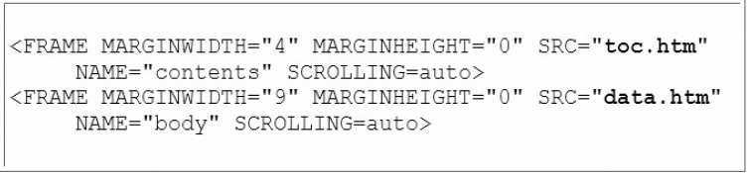

* **Absolute URL**
* the URL= suboptions specify complete URLs using Hypertext Transfer Protocol (HTTP).
* These files can be stored in the same or different locations

Eg:

**ODS HTML BODY** ='c:\records\data.html'

(url='http://mysite.com/myreports/data.html')

**CONTENTS** ='c:\records\toc.html'

(url='http://mysite.com/mycontents/toc.html')

**FRAME** ='c:\records\frame.html';

***Source Code Frame.html***

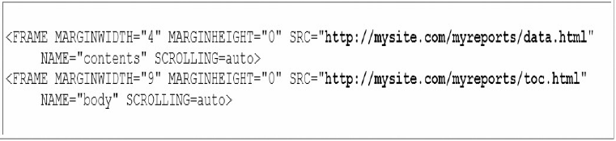

1. **The PATH= Option**

If you do not use the **URL**= suboption, information from the **PATH**= option is added to links and references in the files that are created.

* **PATH**= option

specifies the location where you want to store your **HTML** output

**URL**=**NONE** suboption

prevents **ODS** from using the pathname in any links that it creates in your files

* Basic code

**PATH=***file-location-specification* <(**URL**= **NONE** |*'Uniform-Resource-Locator*')>

*file-location-specification* identifies the location where you want HTML files to be saved. It can be one of the following:

the complete pathname to an aggregate storage location, such as a directory or partitioned data set

a fileref (file shortcut) that has been assigned to a storage location

a SAS catalog (*libname.catalog*).

*Uniform-Resource-Locator* provides a URL for links in the **HTML** files that **ODS** generates. If you specify the keyword NONE, no information from the **PATH**= option appears in the links or references.

* Example：

The PATH= option directs the files data.html, toc.html, and frame.html to the **C:\Records** directory in the Windows operating environment

* **PATH**= Option with **URL=NONE**

The links from the frame file to the body and contents files contain only the HTML filenames data.html and toc.html.

Code:

**ODS** **HTML** **PATH** ='c:\records' (**URL=NONE**)

**BODY**='data.html'

**CONTENTS**='toc.html'

**FRAME**='frame.html';

**PROC** **PRINT** data=clinic.admit;

**RUN**;

**PROC** **PRINT** data=clinic.stress2;

**RUN**;

**ODS HTML CLOSE**;

**ODS** **HTML**;

* **PATH**= Option without the **URL=** Suboption

The links from the frame file to the body and contents files contain the complete pathname, **c:\records\data.html** and **c:\records\toc.html**:

Code:

**ODS** **HTML** **PATH** ='c:\records'

**BODY**='data.html'

**CONTENTS**='toc.html'

**FRAME**='frame.html';

**PROC** **PRINT** data=clinic.admit;

**RUN**;

**PROC** **PRINT** data=clinic.stress2;

**RUN**;

**ODS HTML CLOSE**;

**ODS** **HTML**;

* **PATH**= Option with a Specified **URL**

The links from the frame file to the body and contents files contain the specified URL, **http://mysite.com/myreports/data.html** and **http://mysite.com/myreports/toc.html:**

code

**ODS** **HTML** **PATH** ='c:\records' (**URL**='http://mysite.com/myreports/')

**BODY**='data.html'

**CONTENTS**='toc.html'

**FRAME**='frame.html';

**PROC** **PRINT** data=clinic.admit;

**RUN**;

**PROC** **PRINT** data=clinic.stress2;

**RUN**;

**ODS HTML CLOSE**;

**ODS** **HTML**;

1. Changing the Appearance of HTML Output

* Changing appearance by using **STYLE** = option in the **ODS** statement
* Some of the styles:

|  |  |  |  |  |  |
| --- | --- | --- | --- | --- | --- |
| Banker | BarrettsBlue | Default | HTMLblue | Minimal. | Statistical |

* Basic code:

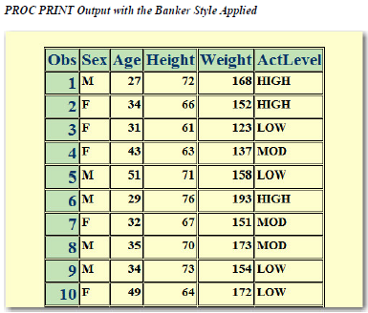**STYLE=***style-name*

where *style-name* is the name of a valid SAS or user-defined style definition. (No quotation)

Eg:

**ODS** **HTML** **BODY**='c:\records\data.html'

**STYLE**=banker;

**PROC** **PRINT** data=clinic.admit label;

**VAR** sex age height weight actlevel;

**RUN**;

**ODS** **HTML** **CLOSE**;

**ODS** **HTML**;

1. Syntax

**LIBNAME** *libref 'SAS-data-library'***;**

**ODS LISTING CLOSE;**

**ODS HTML PATH=***file-specification* <(URL=*'Uniform-Resource-Locator'* | NONE)>

**BODY=***file-specification*

**CONTENTS=**<*file-specification*>

**FRAME=**<*file-specification*>

**STYLE=**<*style-name*>;

**PROC PRINT DATA=***SAS-data-set*;

**RUN**;

**ODS HTML CLOSE**;

**ODS LISTING**;

1. Simple example

**LIBNAME** clinic 'c:\data98\patients';

**ODS HTML PATH** ='c:\records'(url=none)

**BODY** ='data.html'

**CONTENTS** ='toc.html'

**FRAME** ='frame.html'

**STYLE** =brick;

**PROC PRINT DATA** =clinic.admit LABEL;

VAR id sex age height weight actlevel;

LABEL actlevel='Activity Level';

RUN;

**PROC PRINT DATA** =clinic.stress2;

VAR id resthr maxhr rechr;

RUN;

**ODS HTML CLOSE**;

**ODS HTML**;

**练习**

1. If ODS is set to its default settings, what types of output are created by the code below?

**ODS** **HTML** file='c:\myhtml.htm';

**ODS** pdf file='c:\mypdf.pdf';

1. **HTML** and PDF
2. PDF only
3. **HTML**, PDF, and listing
4. No output is created because **ODS** is closed by default.
5. What is the purpose of closing the Listing destination in the code shown below?

**ODS** **LISTING** **CLOSE**;

**ODS** **HTML** ... ;

1. It conserves system resources.
2. It simplifies your program.
3. It makes your program compatible with other hardware platforms.
4. It makes your program compatible with previous versions of SAS software.
5. When the code shown below is run, what file will be loaded by the links in D:\Output\contents.html?

**ODS** **HTML** **BODY**='d:\output\body.html'

**CONTENSTS**='d:\output\contents.html'

**FRAME**='d:\output\frame.html';

1. D:\Output\body.html
2. D:\Output\contents.html
3. D:\Output\frame.html
4. There are no links from the file D:\Output\contents.html.
5. The table of contents created by the **CONTENTS**= option contains a numbered heading for
6. each procedure.
7. each procedure that creates output.
8. each procedure and **DATA** step.
9. each **HTML** file created by your program.
10. What is the purpose of the **PATH**= option?

**ODS HTML PATH**='d:\output' (url=none)

**BODY**='body.html'

**CONTENTS**='contents.html'

**FRAME**='frame.html';

1. It creates absolute link addresses for loading **HTML** files from a server.
2. It creates relative link addresses for loading **HTML** files from a server.
3. It allows **HTML** files to be loaded from a local drive.
4. It specifies the location of **HTML** file output.